**5.WORKING WITH VLOOKUP FUNCTIONS AND PIVOT TABLES**

## VLOOKUP Function

You can use Excel functions to −

* Find values in a range of data - VLOOKUP and HLOOKUP
* Obtain a value or the reference to a value from within a table or range - INDEX
* Obtain the relative position of a specified item in a range of cells - MATCH

You can also combine these functions to get the required results based on the inputs you have.

Using VLOOKUP Function:

The syntax of the VLOOKUP function is

VLOOKUP (lookup_value, table_array, col_index_num, [range_lookup])

Where

* **lookup_value** − is the value you want to look up. Lookup_value can be a value or a reference to a cell. Lookup_value must be in the first column of the range of cells you specify in table_array
* **table_array** − is the range of cells in which the VLOOKUP will search for the lookup_value and the return value. table_array must contain
  + the lookup_value in the first column, and
  + the return value you want to find

**Note** − The first column containing the lookup_value can either be sorted in ascending order or not. However, the result will be based on the order of this column.

* **col_index_num** − is the column number in the table_array that contains the return value. The numbers start with 1 for the left-most column of table-array
* **range_lookup** − is an optional logical value that specifies whether you want VLOOKUP to find an exact match or an approximate match. range_lookup can be
  + omitted, in which case it is assumed to be TRUE and VLOOKUP tries to find an approximate match
  + TRUE, in which case VLOOKUP tries to find an approximate match. In other words, if an exact match is not found, the next largest value that is less than lookup_value is returned
  + FALSE, in which case VLOOKUP tries to find an exact match
  + 1, in which case it is assumed to be TRUE and VLOOKUP tries to find an approximate match
  + 0, in which case it is assumed to be FALSE and VLOOKUP tries to find an exact match

**Note** − If range_lookup is omitted or TRUE or 1, VLOOKUP works correctly only when the first column in table_array is sorted in ascending order. Otherwise, it may result in incorrect values. In such a case, use FALSE for range_lookup.

**Using VLOOKUP Function with range_lookup TRUE:**

Consider a list of student marks. You can obtain the corresponding grades with VLOOKUP from an array containing the marks intervals and pass category.

table_array −

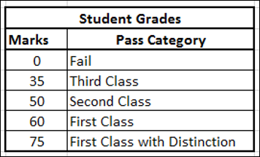

Note that the first column marks based on which the grades are obtained is sorted in ascending order. Hence, using TRUE for range_lookup argument you can get approximate match that is what is required.

Name this array as **Grades**.

It is a good practice to name arrays in this way so that you need not remember the cell ranges. Now, you are ready to look up the grade for the list of marks you have as follows −

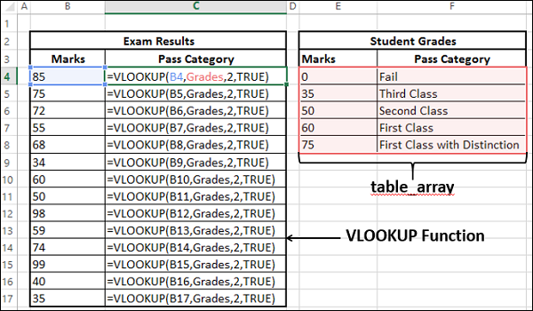

As you can observe,

* **col_index_num** − indicates the column of the return value in table_array is 2
* the **range_lookup** is TRUE
  + The first column containing the lookup value in the table_array grades is in ascending order. Hence, the results will be correct.
  + You can get the return value for approximate matches also. i.e. VLOOKUP computes as follows −

|  |  |
| --- | --- |
| **Marks** | **Pass Category** |
| < 35 | Fail |
| >= 35 and < 50 | Third Class |
| >= 50 and < 60 | Second Class |
| >=60 and < 75 | First Class |
| >= 75 | First Class with Distinction |

You will get the following results −

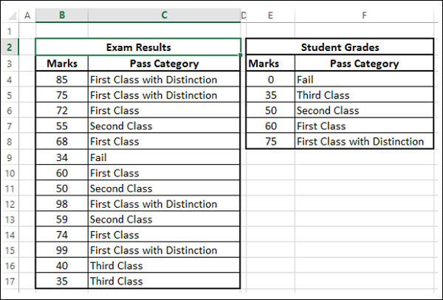

**Using VLOOKUP Function with range_lookup FALSE:**

Consider a list of products containing the Product ID and price for each of the products. The product ID and price will be added to the end of the list whenever a new product is launched. This would mean that the product IDs need not be in ascending order. The product list might be as shown below −

table_array −

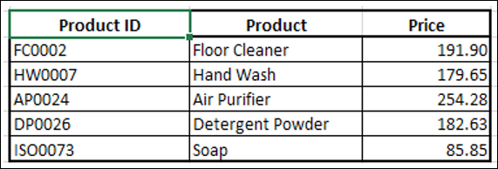

Name this array as ProductInfo.

You can obtain the price of a product given the product ID with the VLOOKUP function as the product ID is in the first column. The price is in column 3 and hence col_index_ num should be 3.

* Use VLOOKUP Function with range_lookup as TRUE
* Use VLOOKUP Function with range_lookup as FALSE

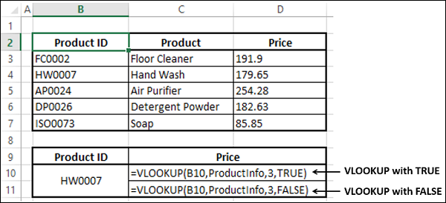

The correct answer is from the ProductInfo array is 171.65. You can check the results.

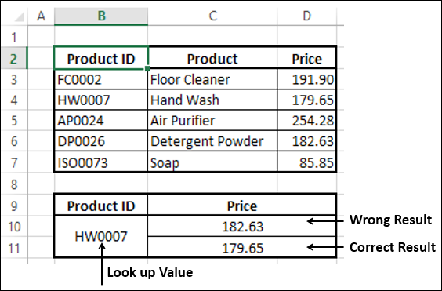

You observe that you got −

* The correct result when range_lookup is FALSE, and
* A wrong result when range_lookup is TRUE.

This is because, the first column in the ProductInfo array is not sorted in ascending order. Hence, remember to use FALSE whenever the data is not sorted.

Using HLOOKUP Function:

You can use **HLOOKUP** function if the data is in rows rather than columns.

**Example:**

Let us take the example of product information. Suppose the array looks as follows −

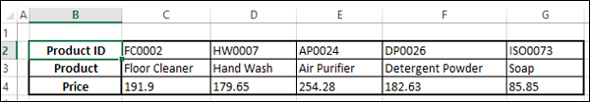

* Name this Array ProductRange. You can find the price of a product given the product ID with HLOOKUP function.

The Syntax of HLOOKUP function is

HLOOKUP (lookup_value, table_array, row_index_num, [range_lookup])

Where

* **lookup_value** − is the value to be found in the first row of the table
* **table_array** − is a table of information in which data is looked up
* **row_index_num** − is the row number in table_array from which the matching value will be returned
* **range_lookup** − is a logical value that specifies whether you want HLOOKUP to find an exact match or an approximate match
* **range_lookup** can be
  + omitted, in which case it is assumed to be TRUE and HLOOKUP tries to find an approximate match
  + TRUE, in which case HLOOKUP tries to find an approximate match. In other words, if an exact match is not found, the next largest value that is less than lookup_value is returned
  + FALSE, in which case HLOOKUP tries to find an exact match
  + 1, in which case it is assumed to be TRUE and HLOOKUP tries to find an approximate match
  + 0, in which case it is assumed to be FALSE and HLOOKUP tries to find an exact match

**Note** − If range_lookup is Omitted or TRUE or 1, HLOOKUP works correctly only when the first column in table_array is sorted in ascending order. Otherwise, it may result in incorrect values. In such a case, use FALSE for range_lookup.

**Using HLOOKUP Function with range_lookup FALSE:**

You can obtain the price of a product given the product ID with the HLOOKUP function as the product ID is in the first row. The price is in row 3 and hence row_index_ num should be 3.

* Use HLOOKUP Function with range_lookup as TRUE.
* Use HLOOKUP Function with range_lookup as FALSE.

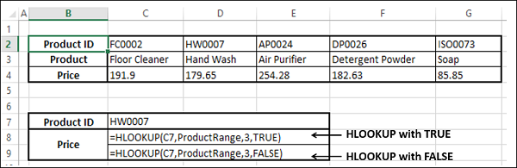

The correct answer from the ProductRange array is 171.65. You can check the results.

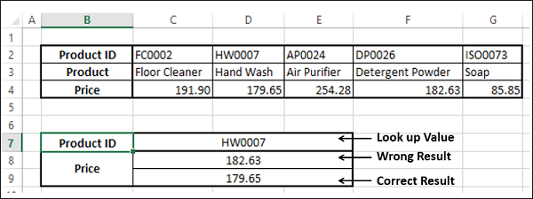

You observe that as in the case of VLOOKUP, you got

* The correct result when range_lookup is FALSE, and
* A wrong result when range_lookup is TRUE.

This is because the first row in the ProductRange array is not sorted in ascending order. Hence, remember to use FALSE whenever the data is not sorted.

**Using HLOOKUP Function with range_lookup TRUE:**

Consider the example of student marks used in VLOOKUP. Suppose you have the data in rows instead of columns as shown in the table given below −

table_array −

Hlookup Function with True

Name this array as GradesRange.

Note that the first row marks based on which the grades are obtained is sorted in ascending order. Hence, using HLOOKUP with TRUE for range_lookup argument, you can get the Grades with approximate match and that is what is required.

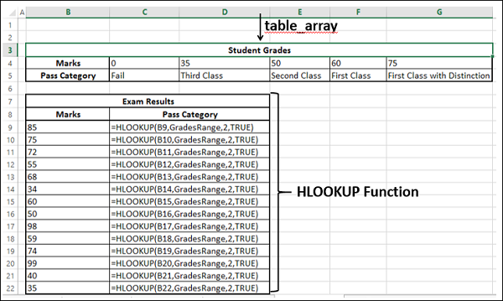

As you can observe,

* **row_index_num** − indicates the column of the return value in table_array is 2
* the **range_lookup** is TRUE
  + The first column containing the lookup value in the table_array Grades is in ascending order. Hence, the results will be correct.
  + You can get the return value for approximate matches also. i.e. HLOOKUP computes as follows −

|  |  |  |  |  |  |
| --- | --- | --- | --- | --- | --- |
| **Marks** | < 35 | >= 35 and < 50 | >= 50 and < 60 | >=60 and < 75 | >= 75 |
| **Pass Category** | Fail | Third Class | Second Class | First Class | First Class with Distinction |

You will get the following results −

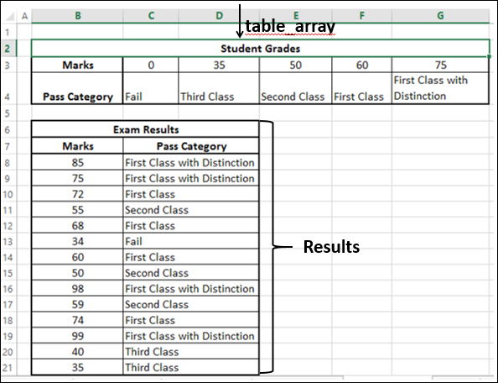

**Using INDEX Function:**

When you have an array of data, you can retrieve a value in the array by specifying the row number and column number of that value in the array.

Consider the following sales data, wherein you find the sales in each of the North, South, East and West regions by the salespersons who are listed.

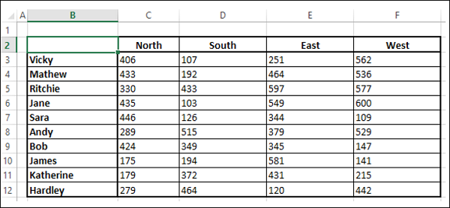

* Name the array as SalesData.

Using INDEX Function, you can find −

* The Sales of any of the Salespersons in a certain Region.
* Total Sales in a Region by all the Salespersons.
* Total Sales by a Salesperson in all the Regions.

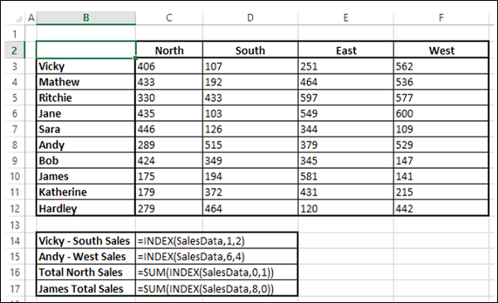

You will get the following results −

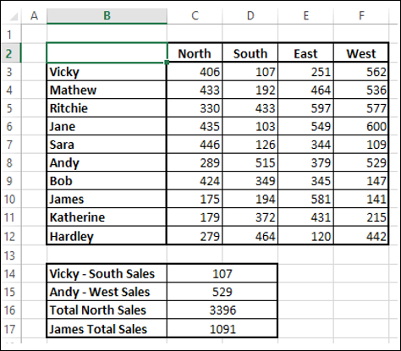

Suppose you do not know the row numbers for the salespersons and column numbers for the regions. Then, you need to find the row number and column number first before you retrieve the value with the index function.

You can do it with the MATCH function as explained in the next section.

**Using MATCH Function:**

If you need the position of an item in a range, you can use the MATCH function. You can combine MATCH and INDEX functions as follows −

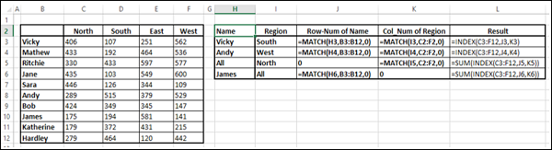

You will get the following results −

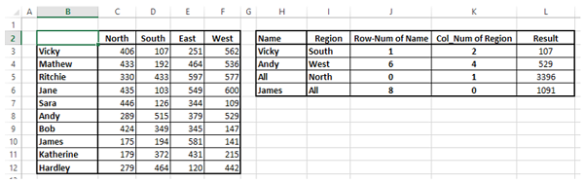

**PIVOT TABLES**

Data analysis on a large set of data is quite often necessary and important. It involves summarizing the data, obtaining the needed values and presenting the results.

Excel provides PivotTable to enable you summarize thousands of data values easily and quickly so as to obtain the required results.

Consider the following table of sales data. From this data, you might have to summarize total sales region wise, month wise, or salesperson wise. The easy way to handle these tasks is to create a PivotTable that you can dynamically modify to summarize the results the way you want.

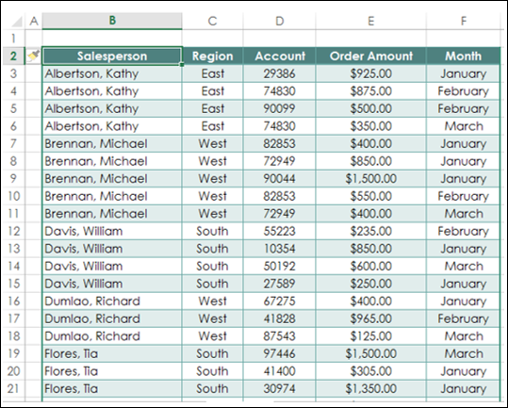

**Creating PivotTable:**

To create PivotTables, ensure the first row has headers.

* Click the table.
* Click the INSERT tab on the Ribbon.
* Click PivotTable in the Tables group. The PivotTable dialog box appears.

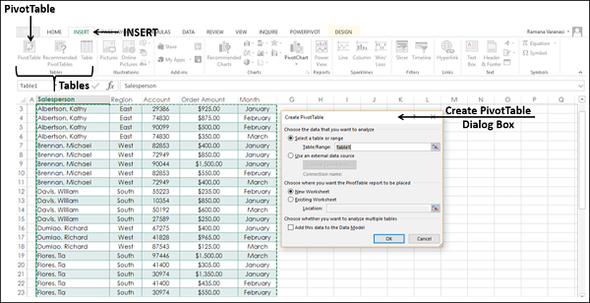

As you can see in the dialog box, you can use either a Table or Range from the current workbook or use an external data source.

* In the Table / Range Box, type the table name.
* Click New Worksheet to tell Excel where to keep the PivotTable.
* Click OK.

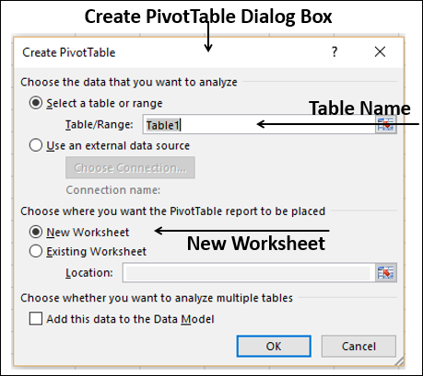

A Blank PivotTable and a PivotTable fields list appear.

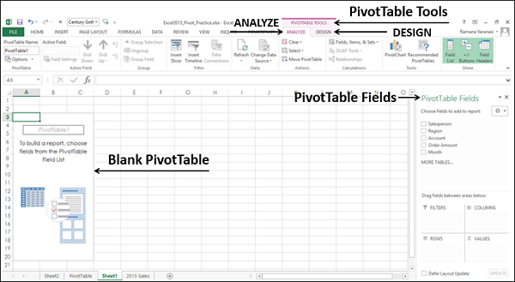

**Recommended PivotTables:**

In case you are new to PivotTables or you do not know which fields to select from the data, you can use the **Recommended PivotTables** that Excel provides.

* Click the data table.
* Click the INSERT tab.
* Click on Recommended PivotTables in the Tables group. The Recommended PivotTables dialog box appears.

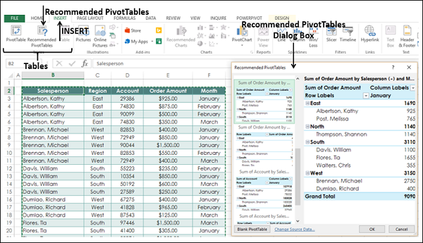

In the recommended PivotTables dialog box, the possible customized PivotTables that suit your data are displayed.

* Click each of the PivotTable options to see the preview on the right side.
* Click the PivotTable Sum of Order Amount by Salesperson and month.

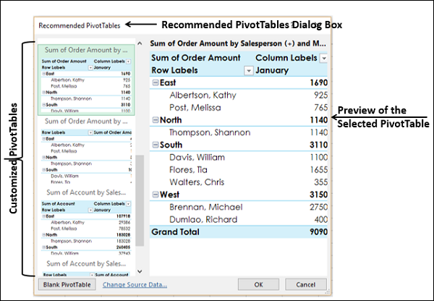

Click OK. The selected PivotTable appears on a new worksheet. You can observe the PivotTable fields that was selected in the PivotTable fields list.

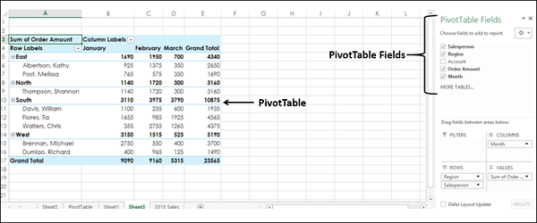

**PivotTable Fields:**

The headers in your data table will appear as the fields in the PivotTable.

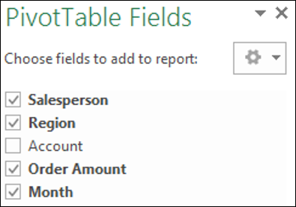

You can select / deselect them to instantly change your PivotTable to display only the information you want and in a way that you want. For example, if you want to display the account information instead of order amount information, deselect Order Amount and select Account.

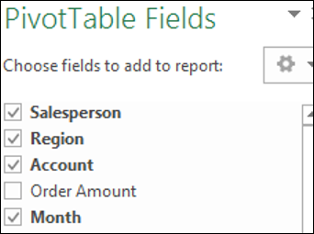

**PivotTable Areas:**

You can even change the Layout of your PivotTable instantly. You can use the PivotTable Areas to accomplish this.

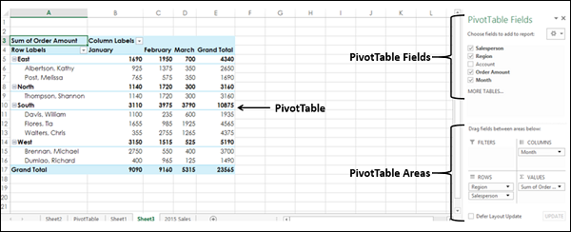

In PivotTable areas, you can choose −

* What fields to display as rows
* What fields to display as columns
* How to summarize your data
* Filters for any of the fields
* When to update your PivotTable Layout
  + You can update it instantly as you drag the fields across areas, or
  + You can defer the update and get it updated only when you click on UPDATE

An instant update helps you to play around with the different Layouts and pick the one that suits your report requirement.

You can just drag the fields across these areas and observe the PivotTable layout as you do it.

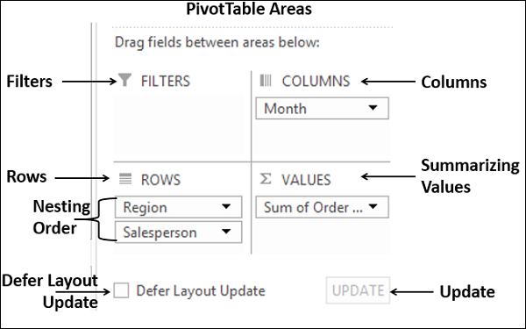

**Nesting in the PivotTable:**

If you have more than one field in any of the areas, then nesting happens in the order you place the fields in that area. You can change the order by dragging the fields and observe how nesting changes. In the above layout options, you can observe that

* Months are in columns.
* Region and salesperson in rows in that order. i.e. salesperson values are nested under region values.
* Summarizing is by Sum of Order Amount.
* No filters are chosen.

The resulting PivotTable is as follows −

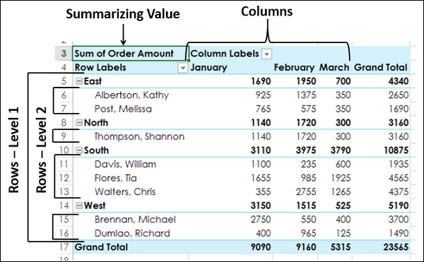

In the PivotTable Areas, in rows, click region and drag it below salesperson such that it looks as follows −

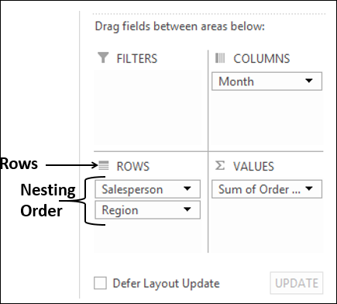

The nesting order changes and the resulting PivotTable is as follows −

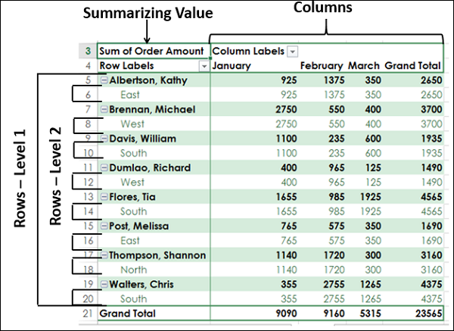

**Note** − You can clearly observe that the layout with the nesting order – Region and then Salesperson yields a better and compact report than the one with the nesting order – Salesperson and then Region. In case Salesperson represents more than one area and you need to summarize the sales by Salesperson, then the second layout would have been a better option.

Filters:

You can assign a Filter to one of the fields so that you can dynamically change the PivotTable based on the values of that field.

Drag Region from Rows to Filters in the PivotTable Areas.

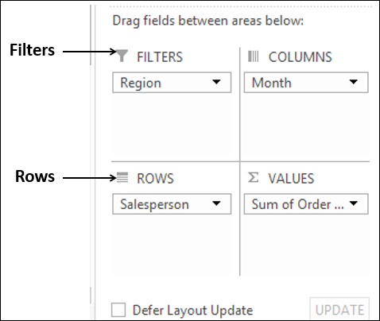

The filter with the label as Region appears above the PivotTable (in case you do not have empty rows above your PivotTable, PivotTable gets pushed down to make space for the Filter.

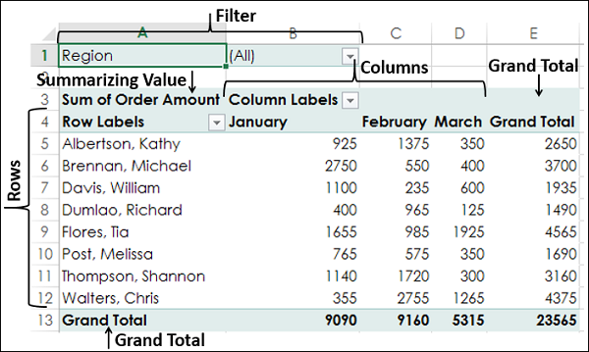

You can see that −

* Salesperson values appear in rows.
* Month values appear in columns.
* Region Filter appears on the top with default selected as ALL.
* Summarizing value is Sum of Order Amount
  + Sum of Order Amount Salesperson-wise appears in the column Grand Total
  + Sum of Order Amount Month-wise appears in the row Grand Total

Click the arrow in the box to the right of the filter region. A drop-down list with the values of the field region appears.

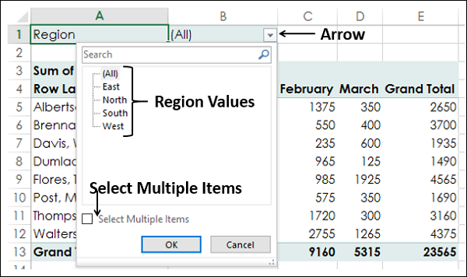

* Check the option **Select Multiple Items**. Check boxes appear for all the values.
* Select South and West and deselect the other values and click OK.

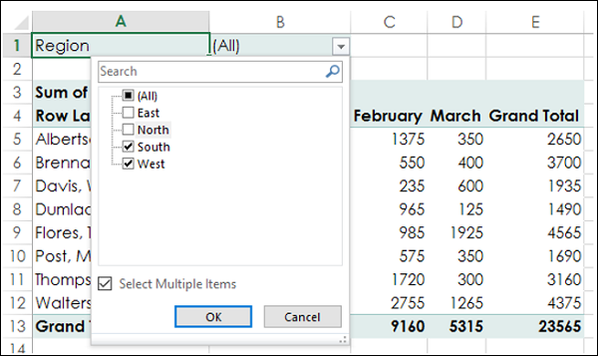

The data pertaining to South and West Regions only will be summarized as shown in the screen shot given below −

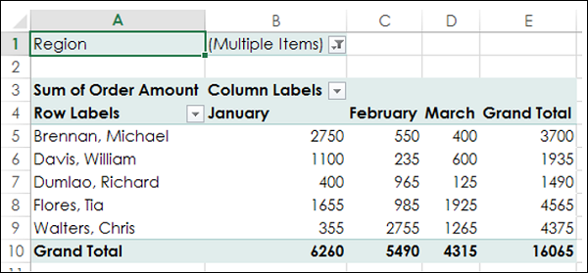

You can see that next to the Filter Region, **Multiple Items** is displayed, indicating that you have selected more than one item. However, how many items and / or which items are selected is not known from the report that is displayed. In such a case, using Slicers is a better option for filtering.

Slicers:

You can use Slicers to have a better clarity on which items the data was filtered.

* Click ANALYZE under PIVOTTABLE TOOLS on the Ribbon.
* Click Insert Slicer in the Filter group. The Insert Slicers box appears. It contains all the fields from your data.
* Select the fields Region and month. Click OK.

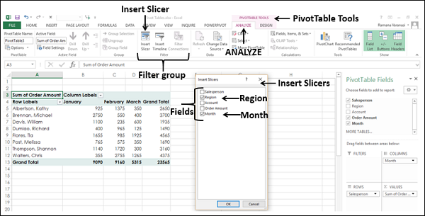

Slicers for each of the selected fields appear with all the values selected by default. Slicer Tools appear on the Ribbon to work on the Slicer settings, look and feel.

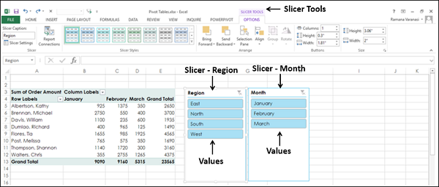

* Select South and West in the Slicer for Region.
* Select February and March in the Slicer for month.
* Keep Ctrl key pressed while selecting multiple values in a Slicer.

Selected items in the Slicers are highlighted. PivotTable with summarized values for the selected items will be displayed.

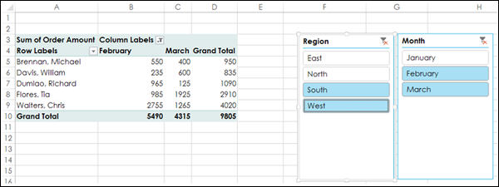

**Summarizing Values by other Calculations:**

In the examples so far, you have seen summarizing values by Sum. However, you can use other calculations also if necessary.

In the PivotTable Fields List

* Select the Field Account.
* Unselect the Field Order Amount.

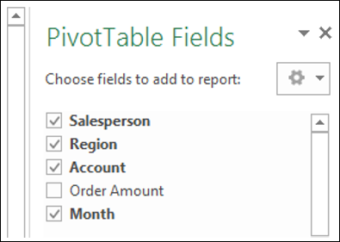

* Drag the field Account to Summarizing Values area. By default, Sum of Account will be displayed.
* Click the arrow on the right side of the box.
* In the drop-down that appears, click Value Field Settings.

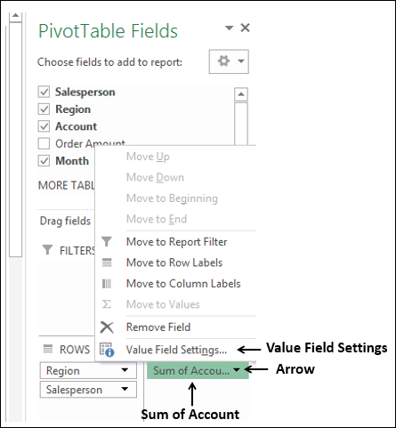

The Value Field Settings box appears. Several types of calculations appear as a list under Summarize value field by −

* Select Count in the list.
* The Custom Name automatically changes to Count of Account. Click OK.

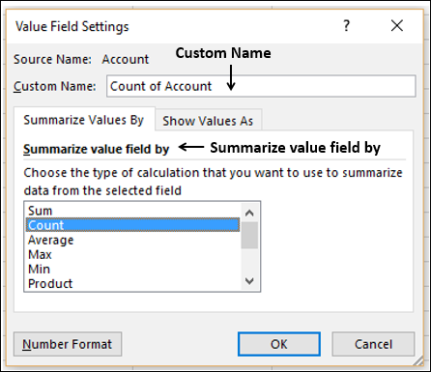

The PivotTable summarizes the Account values by Count.

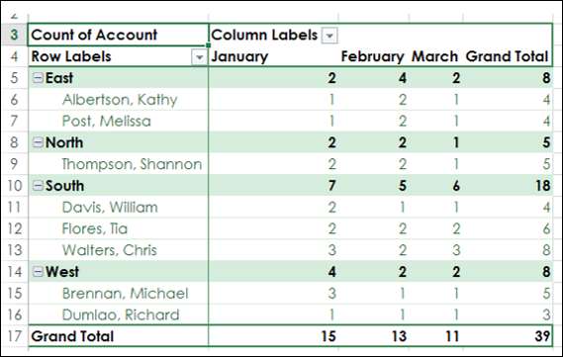

**PivotTable Tools:**

Follow the steps given below to learn to use the PivotTable Tools.

* Select the PivotTable.

The following PivotTable Tools appear on the Ribbon −

* ANALYZE
* DESIGN

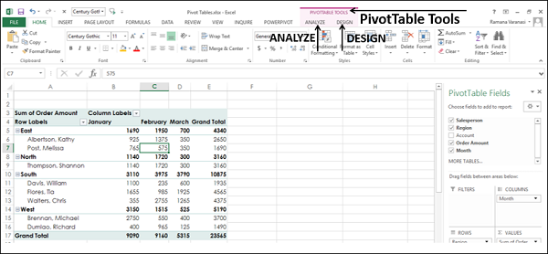

ANALYZE:

Some of the **ANALYZE** Ribbon commands are −

* Set PivotTable Options
* Value Field Settings for the selected Field
* Expand Field
* Collapse Field
* Insert Slicer
* Insert Timeline
* Refresh Data
* Change Data Source
* Move PivotTable
* Solve Order (If there are more calculations)
* PivotChart

DESIGN:

Some of the **DESIGN** Ribbon commands are −

* PivotTable Layout
  + Options for Sub Totals
  + Options for Grand Totals
  + Report Layout Forms
  + Options for Blank Rows
* PivotTable Style Options
* PivotTable Styles

**Expanding and Collapsing Field:**

You can either expand or collapse all items of a selected field in two ways −

* By selecting the symbolPlusorMinusto the left of the selected field.
* By clicking the Expand Field or Collapse Field on the ANALYZE Ribbon.

By selecting the Expand symbolPlusor Collapse symbolMinusto the left of the selected field:

* Select the cell containing East in the PivotTable.
* Click on the Collapse symbolMinusto the left of East.

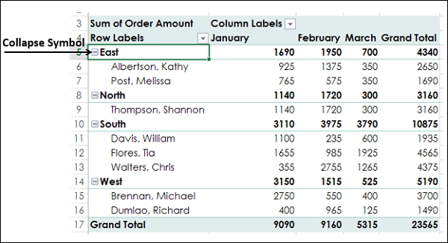

All the items under East will be collapsed. The Collapse symbolMinusto the left of East changes to the Expand symbolPlus.

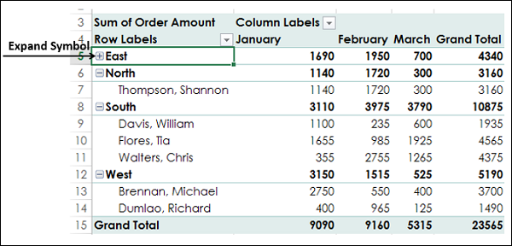

You can observe that only the items below East are collapsed. The rest of the PivotTable items are as they are.

Click the Expand symbolPlusto the left of East. All the items below East will be displayed.

**Using ANALYZE on the Ribbon:**

You can collapse or expand all items in the PivotTable at once with the Expand Field and Collapse Field commands on the Ribbon.

* Click the cell containing East in the PivotTable.
* Click the ANALYZE tab on the Ribbon.
* Click Collapse Field in the Active Field group.

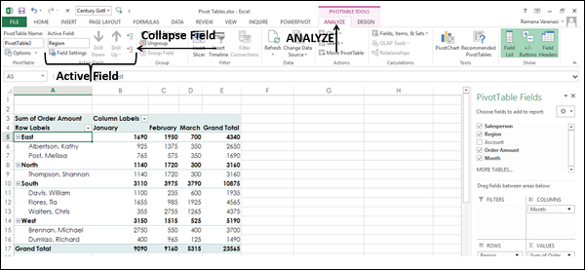

All the items of the field East in the PivotTable will collapse.

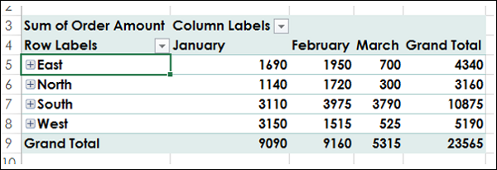

Click Expand Field in the Active Field group.

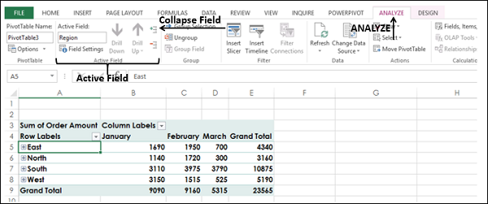

All the items will be displayed.

**Report Presentation Styles:**

You can choose the presentation style for your PivotTable as you would be including it as a report. Select a style that fits into the rest of your presentation or report. However, do not get over bored with the styles because a report that gives an impact in showing the results is always better than a colorful one, which does not highlight the important data points.

* Click East in the PivotTable.
* Click ANALYZE.
* Click Field Settings in Active Field group. The Field Settings dialog box appears.
* Click the Layout & Print tab.
* Check Insert blank line after each item label.

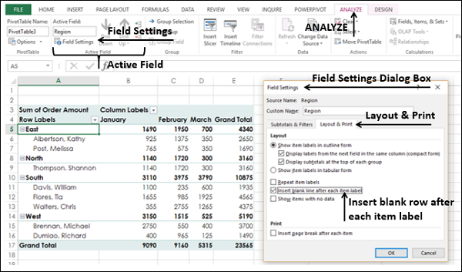

Blank rows will be displayed after each value of the Region field.

You can insert blank rows from the **DESIGN** tab also.

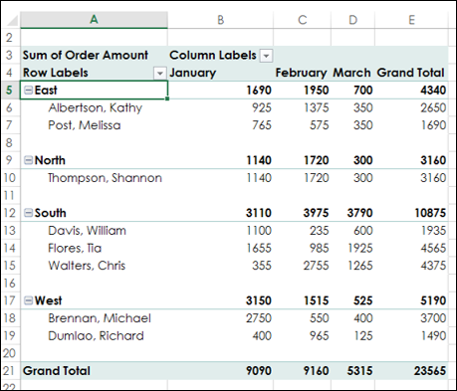

* Click the DESIGN tab.
* Click Report Layout in Layout group.
* Select Show in Outline Form in the drop-down list.

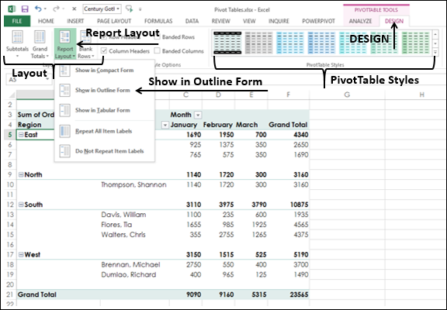

* Hover the mouse over the PivotTable Styles. A preview of the style on which the mouse is placed will appear.
* Select the Style that suits your report.

PivotTable in Outline Form with the selected Style will be displayed.

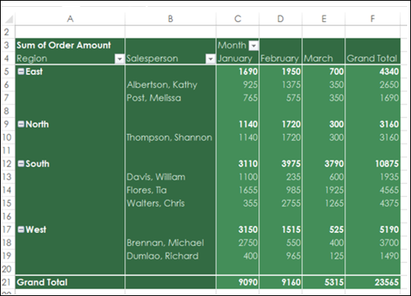

**Timeline in PivotTables:**

To understand how to use Timeline, consider the following example wherein the sales data of various items is given salesperson wise and location wise. There are total 1891 rows of data.

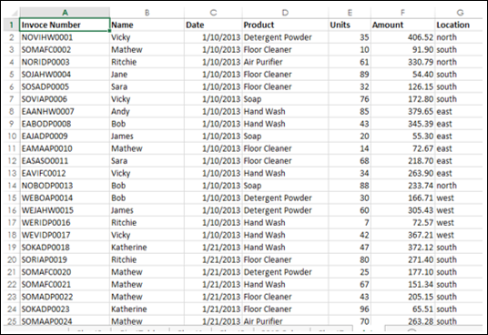

Create a PivotTable from this Range with −

* Location and Salesperson in Rows in that order
* Product in Columns
* Sum of Amount in Summarizing values

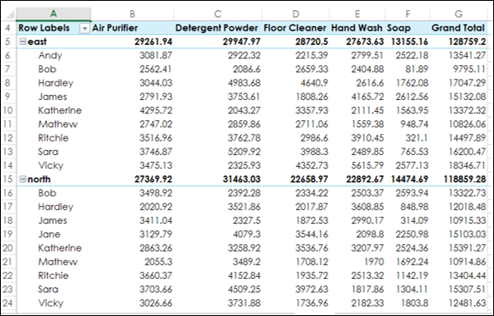

* Click the PivotTable.
* Click INSERT tab.
* Click Timeline in Filters group. The Insert Timelines appears.

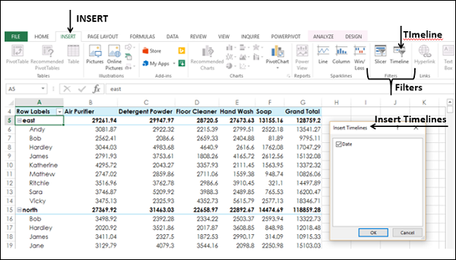

Click Date and click OK. The Timeline dialog box appears and the Timeline Tools appear on the Ribbon.

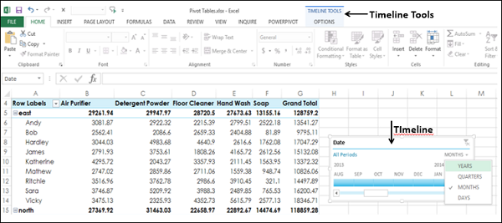

* In Timeline dialog box, select MONTHS.
* From the drop-down list select QUARTERS.
* Click 2014 Q2.
* Keep the Shift key pressed and drag to 2014 Q4.

Timeline is selected to Q2 – Q4 2014.

PivotTable is filtered to this Timeline.

